**Daily Scrum or Standup Meeting**

Team name: ________Group 2_________________

Scrum Master: ______Emily_________________

Date:________10/21_______________________

| **Team Member** | **What did you do since the last scrum?** | **What do you plan to do before the next scrum?** | **What obstacles do you have?** |
| --- | --- | --- | --- |
| Emily Thomas | Started update markup functionality | Finish update markup functionality | Django is giving me errors I don’t recognize.. |
| Maris Hurst | Planned when I will work on this | get the user model updated appropriately | tiiiiime |
| Andre Nguyen | Trying to wrap up the menu model item | Finish the menu model item | Learning how to implement and tie in the menu model item |
|  |  |  |  |
|  |  |  |  |

# Burndown

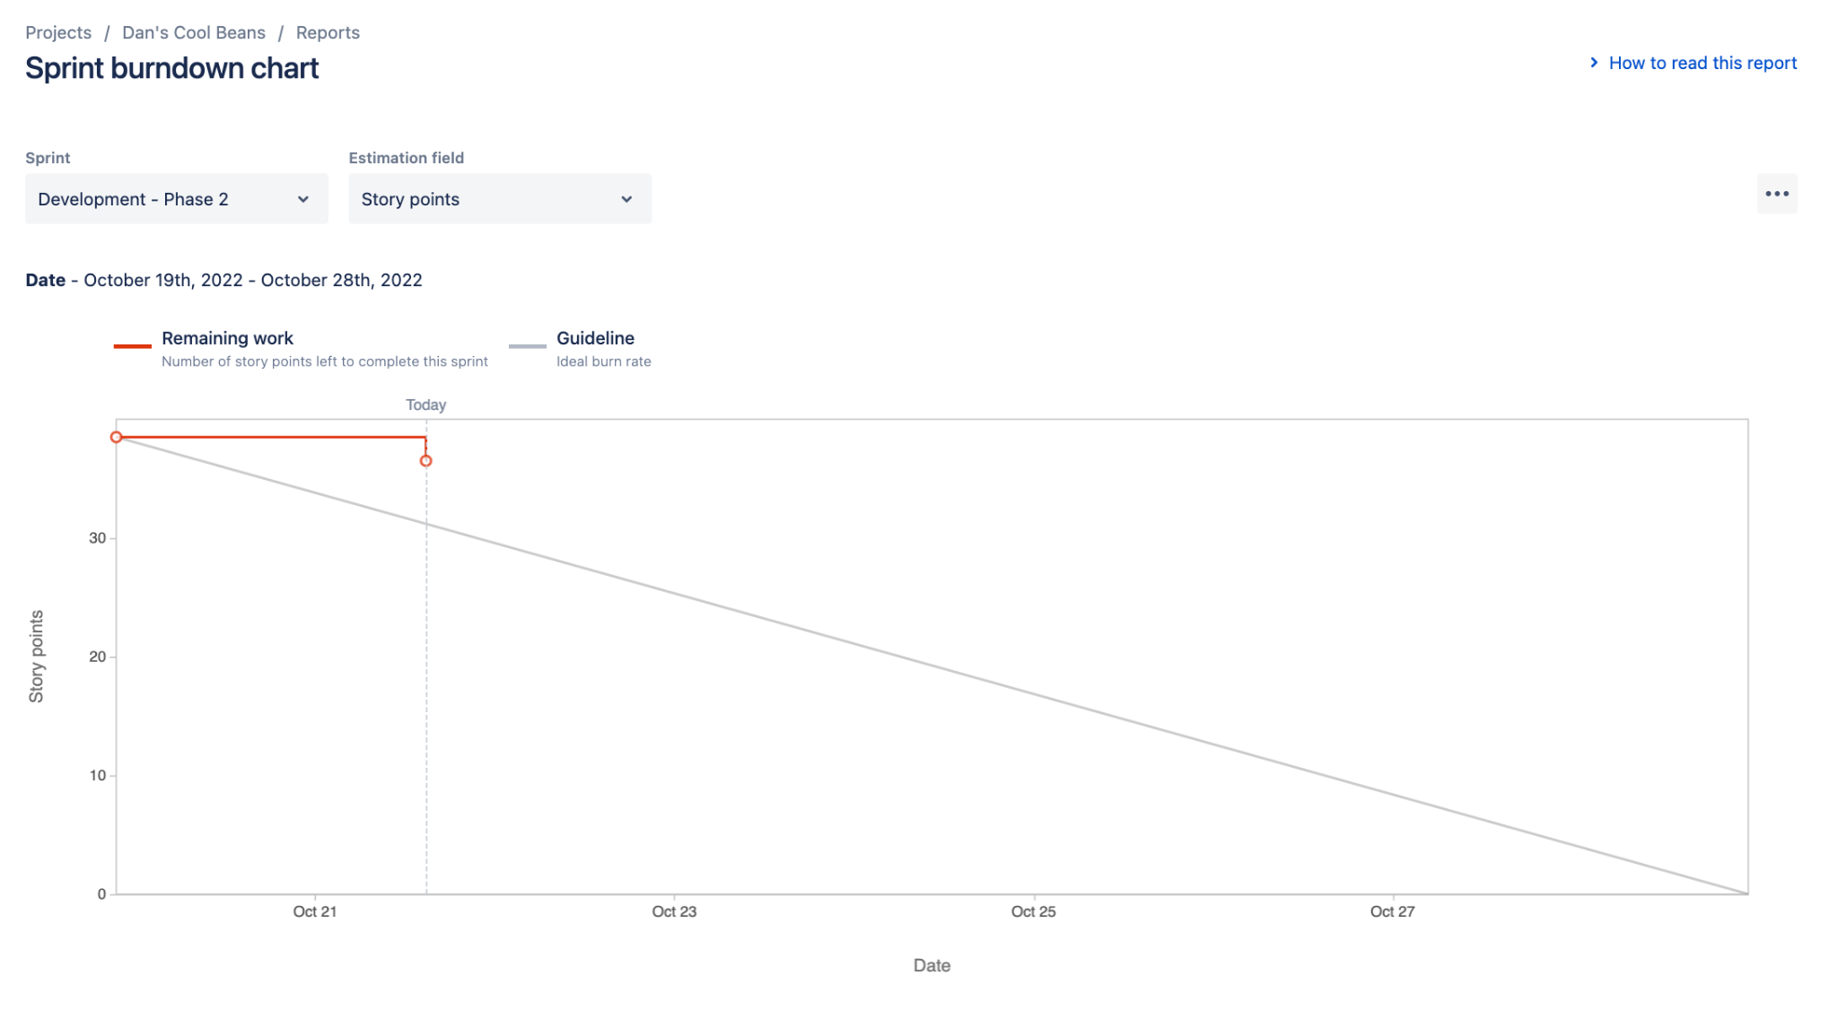

# Screenshot of you project board

